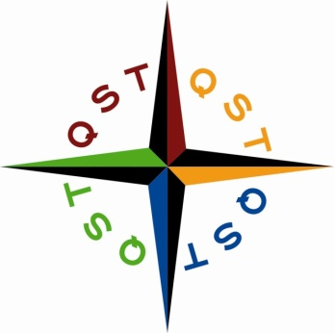
Quest Specialty Travel - London
Corporate Division
18 Westminster Place
London, W1C 2PB
United Kingdom
(0)207-555-0743

Current Date

INSIDE ADDRESS

Dear

Thank you for choosing Quest Specialty Travel to organize a corporate getaway tour for the employees at Southwark Consultants. We are delighted that your employees enjoyed their five-day team building tour to the Scottish Highlands.

Enclosed is our invoice in the amount of XX for the total cost of the following items:

ITEMS

Please click here to view the complete invoice. As we discussed, the cost of each QST London corporate tour is broken into four categories as shown below.

SPREADSHEET

The corporate division of QST London offers companies a wide range of tour opportunities that all provide wonderful opportunities for team building, leadership training, and morale boosting. Following is the list of corporate tours available in 2010.

TOURS

Thank you again for booking your corporate tour with QST London. When you are ready to reward your employees with another QST London corporate tour, please give me a call and I will be happy assist you.

Sincerely,

Your Name
Account Manager

